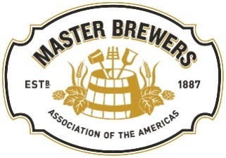

District Fundraiser Resources and Tips
September 2023

Each District of the Master Brewers Association of the Americas (“MBAA”) handles funds and often holds events that raise money for the district. Since Fundraising activities are primarily regulated at the state level in the US, Districts are responsible for researching specific laws for each state they solicit donations in to maintain compliance. We have listed a few resources you can use to review these laws, but please note that this list is not all-encompassing. Be aware that laws may change, so it is crucial for districts to revisit the necessary information before holding meetings that will include any fundraising activities.

Helpful links to get you started:

- IRS video on fundraising guidelines for charities/exempt organizations:
https://www.irsvideos.gov/CharitiesAndNonProfits/501(c)(3)Organizations/FundraisingGuidelinesCharities
- List of state government offices that regulate fundraising: https://www.nasconet.org/resources/state-government/
Details to keep in mind:

- Take care when developing verbiage for how funds will be used.
  - DO- remember funds need to be used to support the mission of MBAA
  - DO- use phrases like “we will be raising funds to put towards our mission of brewing education, including things like, but not limited to, scholarships to the annual conference.”
  - DON’T- use phrases like “funds raised at this event will go towards the (specific) scholarship”. This can restrict the future use of the funds raised. Funds raised for restricted purposes require additional accounting support and should be discussed with National before the funds are solicited.
- Depending on the state, registrations and licensing for fundraising may be required, so do research well before your meeting.
- Keep all necessary documents for tax and legal purposes.
- Districts outside the US are governed by the local fundraising laws of the country/jurisdiction in which the district is organized.

Questions regarding district fundraising activities should be directed to mbaa@mbaa.com

