President | Past President | Technical Chairperson | Vice–President & Membership Chair | Treasurer | Secretary | Board of Governors Representative
PHILIPPE TAYLOR | UELI SCHRADER | KAITLIN VANDENBOSCH | BILL LAWRENCE | DEBBIE MOWAT | JONATHAN MORSE | CHRIS WILLIAMS
PH: (416) 675-8703 | PH: (905) 760-7555  X 178 | PH: (647) 459-6571 | PH: (905) 761-9000 | PH: (905) 684-1727 | PH: (416) 679-7549 | PH: (519) 822-1834  X 4112
Philippe.Taylor@  molsoncoors.com | u.schrader@  beveng.com | kvandenbosch@ millstreetbrewery.com | blawrence@  generalfiltration.com | Debbie@ Back2Health4you.com | jonathan.morse@  molsoncoors.com | cwilliams@sleeman.ca

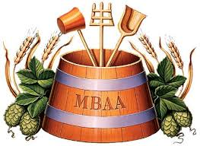

2015 Hop Field Day
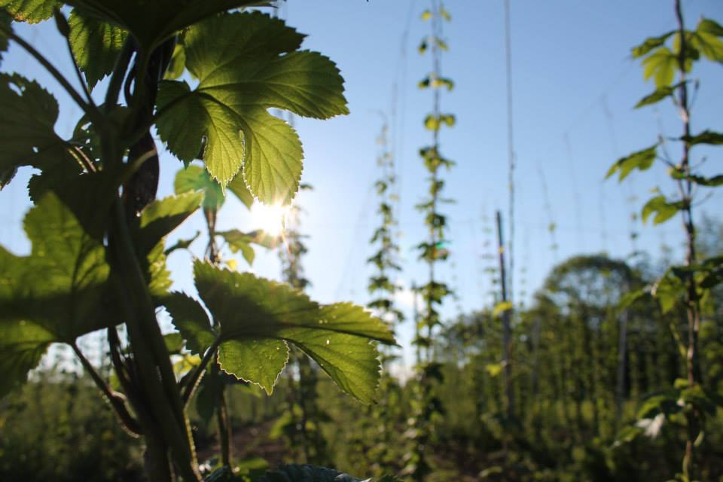
This will be the first Hop Field Day for the Master Brewers’ Association of the Americas Ontario District. This event will bring members to visit a local hop farm and understand how one of the most important ingredients grown, harvested, processed before it ends up in beer.
Come and enjoy a summer day with beer and educational topics at Bighead Hops, Meaford.
Date: 12th August 2015
Itinerary:
Timetable |  | Description | Speaker
7:00 | 7:30 | Gather at Yorkdale Parking Lot
7:30 | 10:00 | Arrive at Bighead Hops | Nicholas Schaut, Bighead Hops
10:00 | 10:15 | Break
10:15 | 12:00 | Field Tour and Hop Rub
12:00 | 12:45 | Presentation | Evan Elford, OMAFRA
12:45 | 14:00 | Lunch at Farm | Steven Vipond, Bruce Wine Bar
14:00 | 14:45 | Arrive at Side Launch Brewery | Michael Hancock, Side Launch Brewing Co.
14:45 | 16:00 | Tour at Side Launch Brewery
16:00 | 18:00 | Arrive at Yorkdale Parking Lot

Registration: Please register on Eventbrite.
https://www.eventbrite.ca/e/mbac-hop-field-day-tickets-17208687648
PW is hops2015

Tickets are $55 per person and includes tours, lunch, beer and transportation.
This session is open to all members. Please bring sun protection (hats, sunscreen etc.) and dress casually.

Please Drink Responsibly. Do Not Drink And Drive.

