President | Past President | Technical Chairperson | Vice–President & Membership Chair | Treasurer | Secretary | Board of Governors Representative
UELI SCHRADER | VERA MORTON | PHILIPPE TAYLOR | BILL LAWRENCE | MARK MURPHY | JONATHAN MORSE | CHRIS WILLIAMS
PH: (905) 760-7555  X 178 | PH: (416) 416-759-6565  X 230 | PH: (416) 675-8703 | PH: (905) 761-9000 | PH: (647) 402-3449 | PH: (416) 679-7549 | PH: (519) 822-1834  X 4112
u.schrader@  beveng.com | vmorton@  millstreetbrewery.com | Philippe.Taylor@  molsoncoors.com | blawrence@  generalfiltration.com | mbactreasurer@gmail.com | jonathan.morse@  molsoncoors.com | cwilliams@sleeman.ca

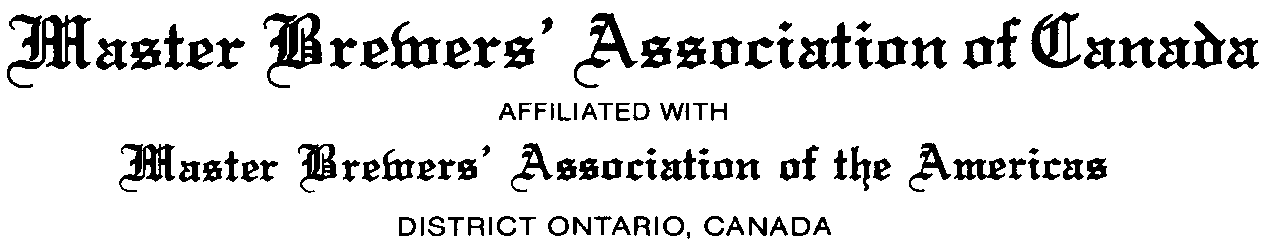

2014 Iron Brewer Competition

We are ready for people to register for the 2014 Iron Brewer Competition (both as attendees and as competitors)!
The event will take place at The Amsterdam Brew House at Queens Quay on September 26th at 2pm.

“What is the Iron Brewer?” you may ask.

The Iron Brewer is a contest to test the skills of members of the Master Brewers of the Americas Ontario District. Contestants are provided with a bag of ingredients - similar to the Iron Chef - and they have to formulate a beer using only the ingredients in the bag. They may use any or all of the ingredients which include base malts, specialty malts, yeasts, and specialty ingredients. At the Iron Brewer Event, the brewers present their beers at and serve samples to members and their guests. Members and guests vote for their top three favourites and the weighted averages determine the Iron Brewer of the year. Finally, all net proceeds are donated to Prostate Canada.

Sampling and finger food is available throughout the event, and of course you can take advantage of the fine selection of Amsterdam food and beer during or after the event.”

We will be accepting 15 single competitors this year: 1 for the host, 3 for last year’s winners, 11 drawn from lottery. We will then have 5 collaboration spots that will be open to all remaining entrants that did not get selected for one of the 15 single spots.

How do you get in the door?

- -Members and Guests: everyone who wishes to attend the event must register via Eventbrite for $25.

- -Iron Brewer Registrants: All those who wish to test their brewing might by competing are to register on Eventbrite for 25$, fill out the registration form (page 2 of the rules attached below), and return it to Paul Dickey with a copy of their Eventbrite ticket. Please note that only single competitor registration is allowed at this time. Collaborations will only be offered after all 15 single spots are filled.

Rules, Registration and event Contact Information:

The link to Eventbrite is https://www.eventbrite.ca/e/mbaa-iron-brewer-2014-tickets-11934234617 ; the password to access the page is “Ontario”.

We look forward to seeing you there!

