Master Brewers’ Association of Canada MBAC, affiliated with
Master Brewers’ Association of the Americas, District Ontario

 |  | Phone | E-mail
Board of Governors Representative | Chris Williams | +1 (519) 822-1834 x 4112 | cwilliams@sleeman.ca
President | Ueli Schrader | +1 (905) 760-7555 x 178 | u.schrader@beveng.com
Past President | Vera Morton | +1 (416) 759-6565 x 230 | vmorton@millstreetbrewery.com
Vice-President and Membership Chair | Bill Lawrence | +1 (905) 761-9000 | blawrence@generalfiltration.com
Secretary | Jonathan Morse | +1 (416) 679-7549 | Jonathan.morse@molsoncoors.com
Treasurer | Mark Murphy | +1 (647) 402-3449 | mbactreasurer@gmail.com
Technical Chairperson | Phil Taylor | +1 (416) 675-8703 | Philippe.Taylor@molsoncoors.com

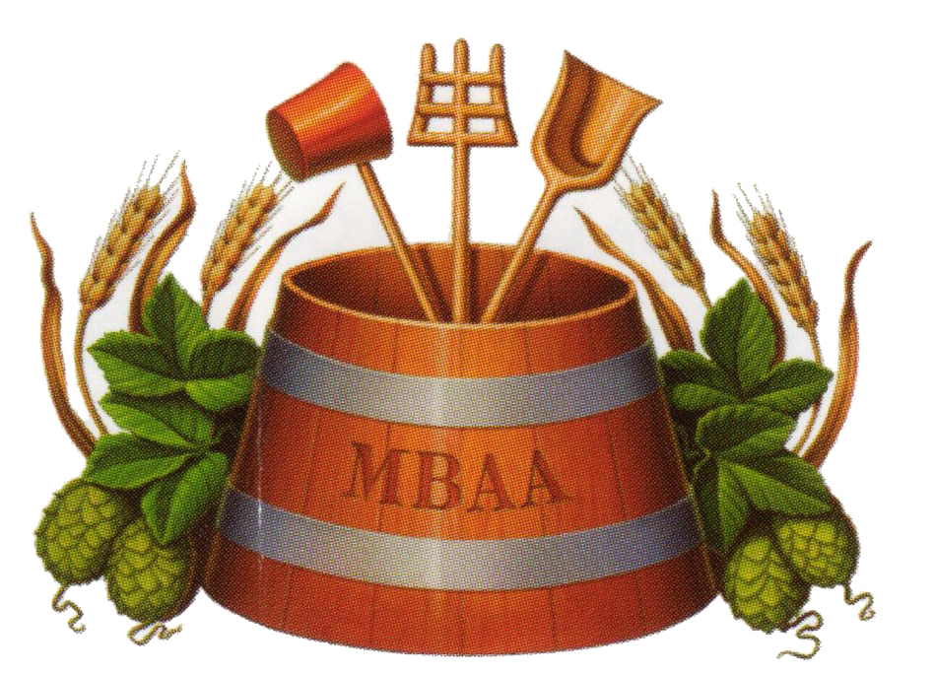

Ontario Technical Conference 2015

101 Years of Master Brewers’ Association of Canada
Location: The Westin Bristol Place Toronto Airport Hotel, 950 Dixon Road, Toronto, Ontario M9W 5N4, Canada
Parking fee is included in the conference fee and complimentary for all attendants.
Time: Thursday, 2015-January-29 full day.
Thursday evening the traditional “Beer Stube”, starting around 20:00h.
Friday, 2015-January-30 half day (ending around 14:30h)

General.
The MBAA District Ontario Technical Conference has gained a worldwide reputation as one of the leading forums for the presentation and exchange of technical information relating to the brewing industry. The conference allows delegates to listen and direct questions to a diverse group of technical people.
On Thursday 2015-January-29 enjoy technical presentations, the full course lunch, and meet friends.
At the famous “Beer Stube” (open from 19:30h (7:30pm) until midnight) make new acquaintances or meet known ones enjoying the evening.
On Friday 2015-January-30 the technical conference will continue until 12:30pm, followed by a full course lunch
The conference registration desk will be open Thursday 08:00h (8 am to 16:00h (4 pm) and Friday 08:00h (8 am) to noon.

Registration: Please register online via Eventbrite: https://www.eventbrite.ca/e/mbac-ontario-technical-conference-tickets-14752455993
Conference cost for pre-registered MBAA members is $ 195.00 (CAD or USD)
Conference cost for MBAA members who do not pre-register is $ 230.00 (CAD or USD).
Conference cost for non-members is $ 290.00 (CAD or USD).
Conference cost for students and honorary members is $ 150.00 (CAD or USD). Note: please present a valid student ID at the door.
*Please note that a late registration penalty of 35$ will be added to the above prices for all tickets purchased after January 21st, 2015.
Payment can be made via Eventbrite or at the door:
1) https://www.eventbrite.ca/e/mbac-ontario-technical-conference-tickets-14752455993
2) Payment at the door will be at the late registration rates (HST # 896735628). Receipts will be available at the desk (cheques and cash only)

Schedule.

Thursday 2015-Jan-29
08:00h – 09:00h Sutton Foyer Breakfast (Continental Breakfast Buffet)
08:00h – 09:00h Registration and to receive your conference papers.
09:00h Sutton Hall A and B Technical Session: Sustainability and Environment
Steve Beauchense Beau’s All Natural Brewing Company: BCORP Certification
Ueli Schrader Beverage Engineering; Brewery CO2 Recovery
10:30h – 11:00h Coffee break
Fred Scheer Krones AG: Energy Efficiency in the Brewhouse
Michael Fagan Bloom Center for Sustainability: Waste Water Treatment

12:30h Sutton Hall C Lunch-break (Lunch will be provided)

14:00h Sutton Hall A and B General Session
Tony Formby 2x4 Brewing and Imports: Exporting beer to the USA
14:45h Sutton Hall A and B Panel Session: Alternative Beer Carbonation
Jerry Vietz Unibroue; Bottle Conditioning
Marek Mikunda Steam Whistle; Carbonation in Fermenter
Charles MacLean MacLean’s Ales; Cask Conditioning

19:30h at the Bristol Suite Beer-Stube. This might last longer...

Friday 2015-Jan-30
08:00h – 09:00h Breakfast (Continental Breakfast Buffet)
08:00h – 09:00h Registration and to receive your conference papers.
09:00h Sutton Hall A and B Keynote
Garett Oliver Brooklyn Brewery; Brewmaster
10:15h Sutton Hall A and B Technical Session
Luke Chapman Beer Canada; The Industry Bottle in Canada
11:00h – 11:30h Coffee break
11:30h Sutton Hall A and B Technical Session: Adapting Beer Recipes Between Breweries
Kevin Hryclik Blue House Consulting
Paul Dickey Cheshire Valley Brewing

13:00h – 14:30h Lunch-break (Lunch will be provided, Sutton Hall C)
14:30h End of Technical Sessions, Farewell

Badges Please, wear your MBAA badges, thank you.
If you are a MBAA District Ontario member you and do not have a badge, please, contact mailto:cwilliams@sleeman.ca?subject=MBAA member badge to get one.

Hotel Rooms.
Hotel Our premier choice: The Westin Bristol Place hotel enjoys a well-deserved reputation as one of the premier hotels on the Airport Strip. If you plan to stay at the hotel, please reserve directly through the hotel. Please, book your reservation prior to January 7th, 2015 at the discounted rate.
THE WESTIN BRISTOL PLACE TORONTO AIRPORT.
950 Dixon Road, Toronto, Ontario M9W 5N4, Canada.
Telephone +1 (416) 675 - 9444
Fax +1 (416) 675 - 2037
Web http://www.westinbristolplace.com

To book your room at the special rate of 152.00 CAD per room per night, please, either call via phone or click on the web-link as given below:
Phone for reservation: +1 (800) 937 8461 or +1 (800) WESTIN1 and state that you are visiting the Master Brewers Conference Ontario
Web-link https://www.starwoodmeeting.com/StarGroupsWeb/res?id=1412056308&key=11BBE7FA

Please, note that for the hotel guests the wireless Internet connection is complimentary in the lobby only. In the rooms there is a charge for Internet usage. Please, book your rooms January 7th, 2015. The rates will change after that day. If you need to cancel your hotel rooms, please, give 48 hours notice prior to arrival date.
Please, note that the hotel provides a completely smoke-free environment.
Do NOT drink and drive Enjoy the products of our industry and craftsmen responsibly. Do not drink and drive.

Visit our website at http://www.mbaa.com/Districts/Ontario

Vegetarian? Please, let us know if you prefer vegetarian lunch. Just send an email to Philippe.Taylor@MoslonCoors.com and let him know. Thank You.

