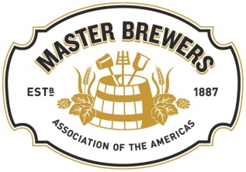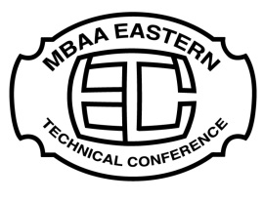
Spring 2018 ETC – Atlantic City, New Jersey
District Mid-Atlantic joined forces with District Philadelphia and District New York to host the Spring 2018 ETC (Eastern Technical Conference) in Atlantic City, New Jersey. The meeting spanned two days, March 23-24th, at the historic Claridge Hotel. The meeting was very successful with 250 attendees, from 20 US States and DC, as well as from Canada, and Belgium. The group consisted of a broad spectrum of leading industry experts, large and small breweries, numerous vendors and suppliers, and those who are just beer enthusiasts and love the craft. It is also noteworthy that there were four past National Presidents in attendance at the ETC (Mike Sutton, Joe Hertrich, Roy Johnson, and Tom Eplett).
Master Brewers and District Mid-Atlantic are committed to promoting the advancement of the brewing industry through an open educational forum, with strong technical sessions addressing all aspects relevant to the modern brewer. This year’s ETC consisted of numerous technical sessions and posters that delivered our goal in broadening the education and understanding of all in attendance. Each presentation resulted in thought provoking discussion and learnings afterwards, as well.
Over 2 days, the Technical sessions consisted of the following:
- ​“FAN and Flavor Impacts: The Fundamentals of a Brewer's Dilemma” - Pattie Aron, Rahr Malting
- “Dry Hopping and Its Effects on Beer Bitterness, the IBU Test, pH, and Beer Foam” - John Paul Maye, Hopsteiner
- “An Innovation For Improving Performance and Flexibility of Unitank Fermentations” - Gregg Norris, GEA
- “Characterization of Kveik, Landrace Norwegian Brewing Yeast” - Richard Preiss, Escarpment Labs
- “Sooner Rather Than Later: Six Things That Can Go a Long Way Toward Ensuring Higher Quality Beer” - Andy Tveekrem, Market Garden Breweries
- “The Yeasts of Tomorrow” - Stijn Mertens, KU Leuven
- “Understanding Beer and Foam Color” - Bob Hansen, Briess Malt
- “New Hop Varieties-The Art and Science” - Tim Kostelecky, John I. Haas
- “Fermentation Flavors and the Influence of Various Operational Parameters on their Production” - Bill Maca, HWM Yeast Solutions
- “Challenges of All Malt Brewing with North American Two Row Barley” - Joe Hertrich
In addition to the technical sessions, throughout the weekend numerous well written and informational posters were available to read and discuss with the authors, on a large range of topics.
The posters on display consisted of the following:
- “A Comparison of Selected Lactic Acid Bacteria For Use in the Production of Sour Wort and Beer” – Timothy Lozen, Bell’s Brewery, Inc.
- “Risks and Rewards of Anaerobic Digester Systems for Craft Brewery Wastewater Treatment” – Manaf Farham, EMG International, Inc.
- “The Importance of Cleanliness: An Overview of CIP and COP Systems“ - Blake Kinnett, M.G. Newell Corporation
- “Kona Longboard Lager: Life Cycle Analysis” – Julia Persen, Craft Brew Alliance
- “Optimization of Premature Yeast Flocculation (PYF) Factor Assay” – Jigar Brown, Pattie Aron, Rahr Malting Co.
- “GY7B is a Novel Yeast Capable of Rapidly Producing Sour Beer Without Bacteria” – Gabriella DeMichelle, Matthew Farber, PhD
- “Development of a Selective Media For the Detection of Diastaticus in the Brewery” – Kent Pham, Gabriella DeMichelle, Matthew Farber, PhD
- “Evaluation of Culture Medias (YM and YNB) and Copper sulfate Concentrations for Wild Yeast Detection” – Maydelin H. Espinosa, Molson Coors Brewing Company
- “Sensory Thresholds of Hop Volatile Compounds in Beer” – Meghan Peltz, Sierra Nevada Brewing Company
- “Detection of Glass Bottle Defects Prior to Filling” – Jeff DeVoy, HEUFT USA
- “Dry-hopping’s Effect on Beer Foam” – Dr. John Paul Maye, Hopsteiner
- “Capturing Terroir: Isolation and Characterization of Local Wild Yeast” – Dr. Kari Murad, The College of Saint Rose
Also, as a special treat for those in attendance, Friday night, Steve Dresler (retired Sierra Nevada) spoke to the group about the topic of “A Career in Craft”, as our key note speaker.
As if the full two days of technical sessions, posters, and great dialog was not enough, there was a large area available for vendors and suppliers to set up exhibits, demonstrations, and information booths to further quench the thirst for more knowledge, and present ideas of new solutions and products. These exhibits were available all weekend long for everyone to have an opportunity to see the products, talk to the vendors, and even pick up some swag along the way.
In closing, we would like to thank the speakers and the sponsors of the event because without their time, and generous donations, we couldn’t host such a fantastic event. Thank you to District Philadelphia and District New York for their help and support, as well. Thank you to the MBAA Executive Committee/Headquarters for sending Susan to help with registration, and other administrative needs, as well as National for recognizing and supporting taking courses such as HACCP to the district levels. In the Spring, District Philadelphia will be offering HACCP training as a part of their meeting, as well as having Charlie Bamforth as their guest speaker. Please take the time to visit District Philadelphia’s website for additional details.
Facebook Website
There is a long list of reasons of why you should join MBAA. One of the most beneficial incentives, is being able to access all of the information presented at the ETC as well as thousands of other papers, and educational tools to either help you be a better brewer or just enjoy and understand the business we are in more fully. All of the presentations and videos from the ETC will be on District Mid-Atlantic’s website in the coming weeks. Please visit our website and Facebook page often to see upcoming events and news. Thank you to all who were in attendance and looking forward to seeing many of you at our next district meeting.
Cheers!
-Brian Jackson, District Mid-Atlantic Vice President & District Secretary
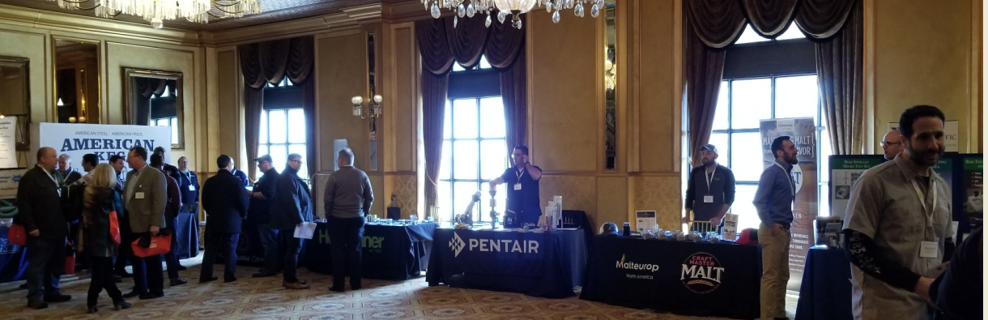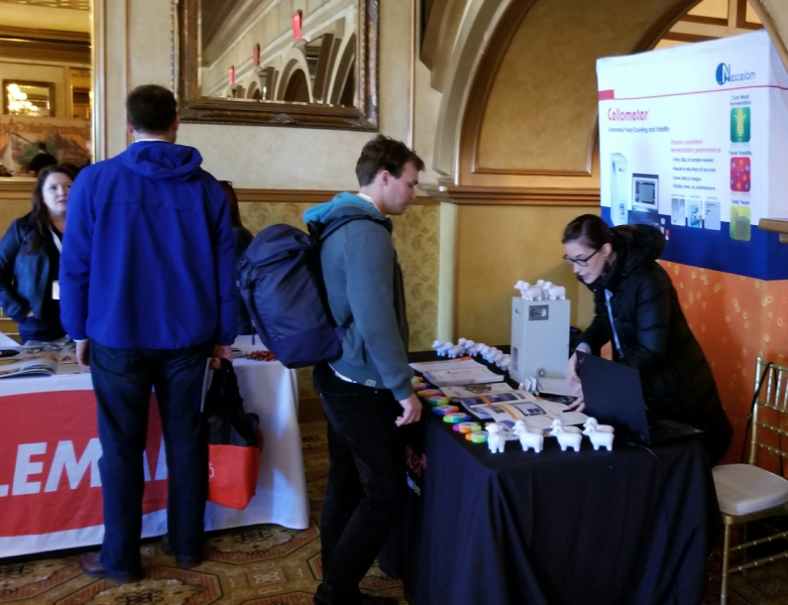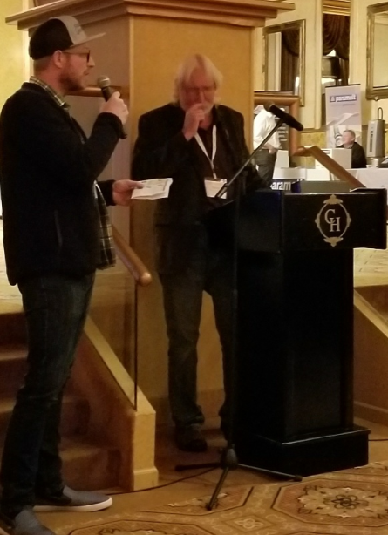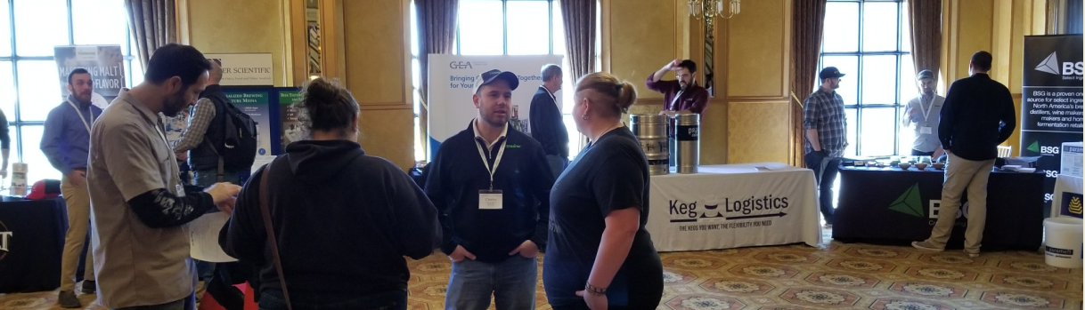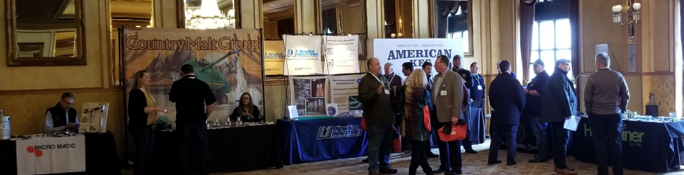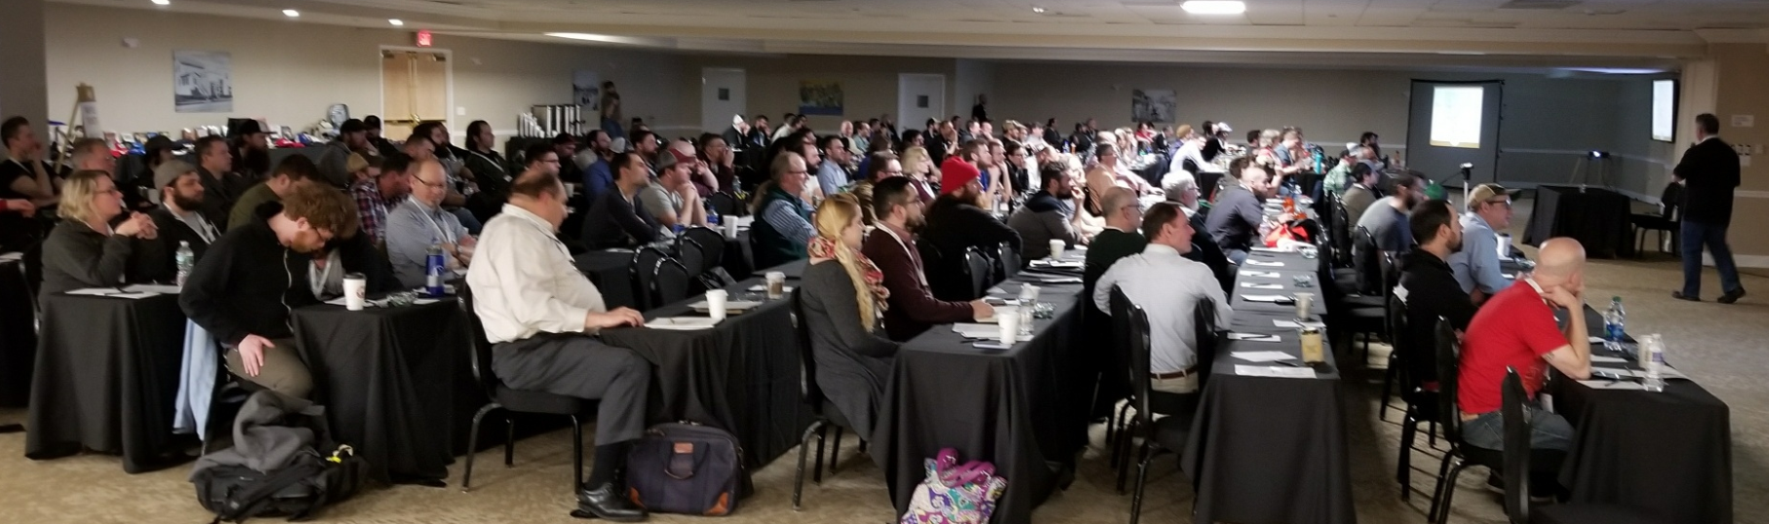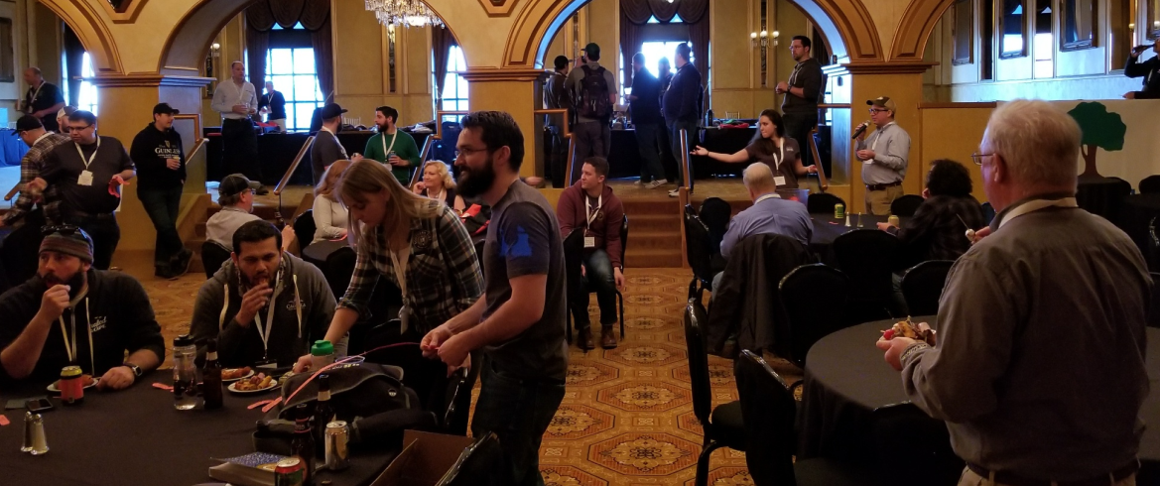
EXHIBITORS

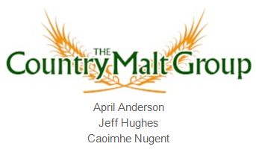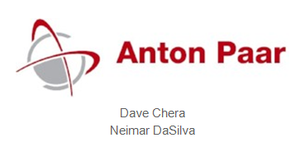

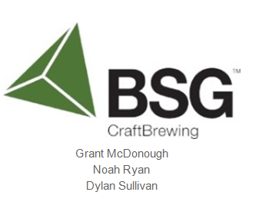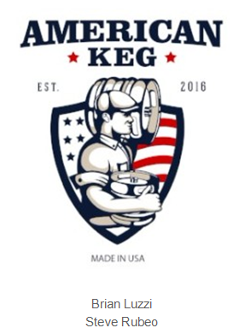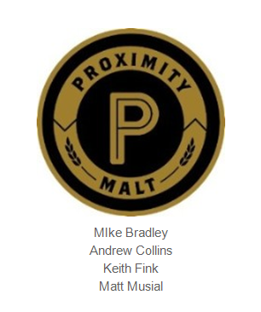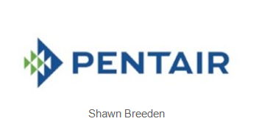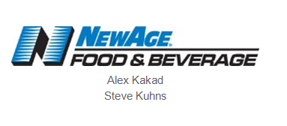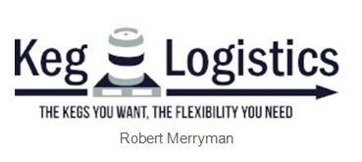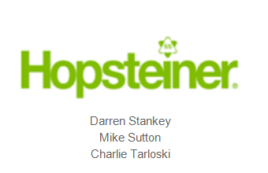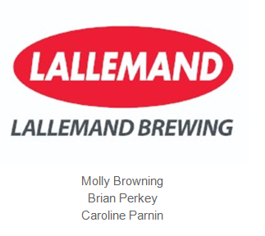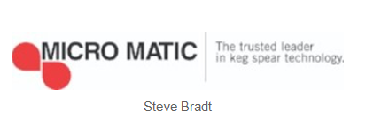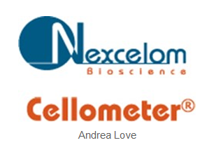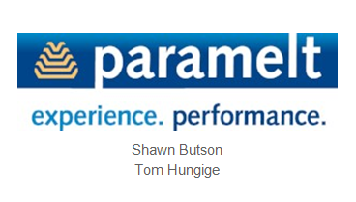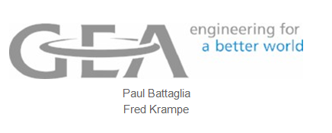
Sponsors
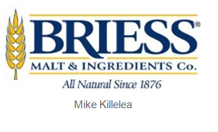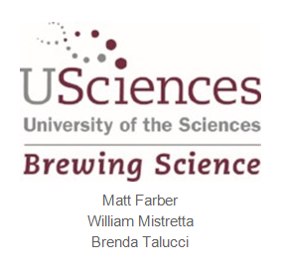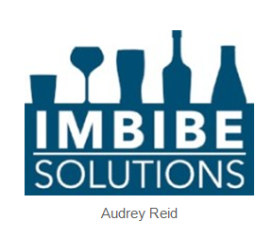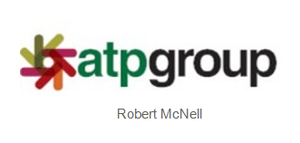
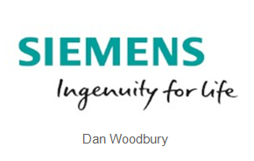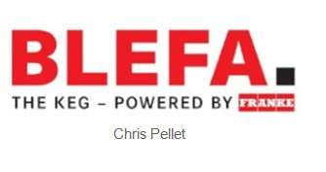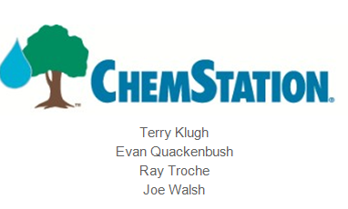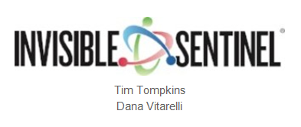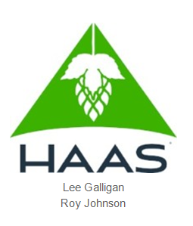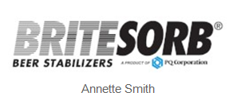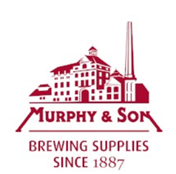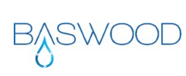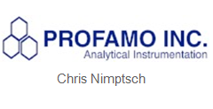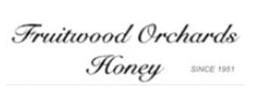
Thanks To Our Beer Donors!
