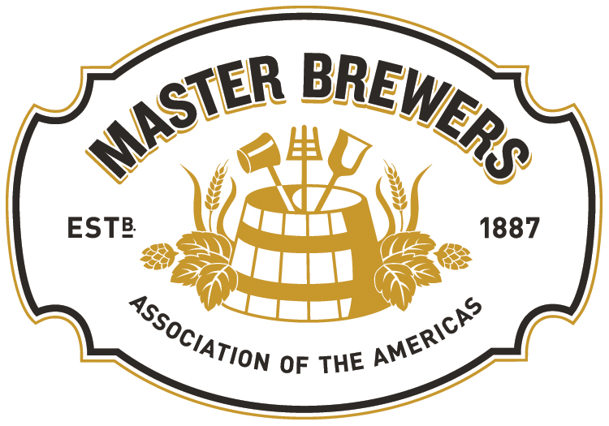Master Brewers District Online Registration

Event Name
Begin Date End Date
Start Time End Time
Venue
Address
City/State
Registration Closing – Registration will stay open through the meeting unless one or both are specified.
Date: __________________________________________________ (close on given date)
Capacity: _______________________________________________ (close when capacity reached)
Registration Fees (Credit card [VISA, MC, Amex, Discover] and Paypal payments are accepted for online registrations.)
Provide fees and cut off dates for all registration types (member, nonmember, student) and fee structure (early, regular, late), as applicable.
 | Early fee (if applicable) | Regular Fee | Late Fee (if applicable)
Cut off dates |  | 05/15/2019 | N/A
Member |  | $50 | $75
Nonmember
Student
Refunds/Cancellations
Are refunds allowed? If yes, deadline to receive refund? MM/DD/YYYY
Cancellation fee (if any) $
Are you planning any ticketed events during your meeting?  Yes  No
If yes, specify the name of the event(s), pricing, and maximum number?_______________________________
Also indicate if full meeting registration is required to attend ticketed event.  Yes  No
Complimentary registrations (speakers, etc.)?  Yes  No (if yes, please enter name and email addresses for those to receive complimentary registrations)
Onsite Payment
If you have internet access at the meeting, the attendee can register online. An email would be sent to the registrant. Cash payment can be collected onsite.
Registration Materials and Processing Fees
- 3.5% registration processing fee will be charged for all transactions
- Master Brewers will provide the final list of registrants as an Excel file so that you can merge and print your own badges.
Organizer contact information
Name
Company
Address
City / State / Postal Code
Email
Send registration report to organizer each week during registration period?  Yes  No
INHOUSE USE ONLY
GLS (KG to provide) TA (KF to provide)

